OUTREACH SCHOOLS EXAMINATION BOARD
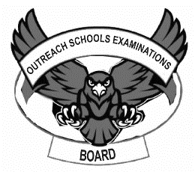
BEGINNING OF TERM III EXAMINATION 2023
PRIMARY THREE
MATHEMATICS
Time Allowed: 2hours 30 minutes
A
B
For Examiner’s
use only
TOTAL

Name: ________________________________________________

School: ________________________________________________

Class: __________________________________________________

SECTION A (40 MARKS)

- Add: 2 + 5 = | - Find the next number in the sequence.  20 , 25 , 30 , 35 , 40 , _____
- Work out and fill in the missing number.  + 5 = 12 | - Subtract : 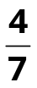 - 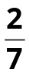 =
- In the space below, draw a rectangle. | - How many days are in 2 weeks?
- Write 10 in Roman numerals. | - Write 125 in words.
- Name the set given below.  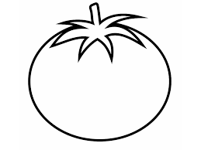  __________________ | - Simplify:  4 books + 2 books =
- Write the shaded fraction in words.  _________________________ | - Work out:  Kg g  7 500  + 2 400
- Find the value of 7 tens. | - Subtract 74 from 82.
- Mary bought 2 tins of ice-cream at sh. 1000 each. How much money did she spend altogether? | - Work out 2 + 3 using a number line below.  0 1 2 3 4 5 6 7 8
- Which digit is in the place value of tens in 6 3 4 0? | - How many minutes are in half of an hour? (1 hour = 60 minutes)
- Multiply: 4 2 2  x 3 | - Share 18 mangoes equally among three friends. How many mangoes did each get?
SECTION B (60 MARKS)
- Use + , - , ÷ or x to complete correctly.  - 8 ____________ 2 = 10  - 2 ____________ 5 = 10  - 20 ____________ 2 = 10  - 12 ____________ 2 = 10 | (8 marks)
- Study the figure below and answer the questions that  follow.  a  b  3cm  5cm  - Find ; i) a =  ii) b = | (1 mark)  (1 mark)
- Find the total distance around the figure. | (2 marks)
- Work out:  (a) 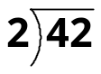 (b) 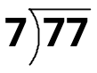 | (4 marks)
- a) Find the number that has been expanded.  600 + 10 + 4 | (2 marks)
b) Show the expanded number in (a) above on the abacus.  H T O | (2 marks)
- a. Add: m cm b. Subtract: L ml  4 30 10 500  + 2 18 - 5 250 | (2 marks @)
- Aviv is 8 years old. Anna is 10 years old.  - Who is older? | (1 mark)
- How old will Aviv be in 3 years to come? | (2 marks)
- Find their total age now. | (2marks)
- Below is a list of items which were bought by a parent.  A book sh. 1000  A rubber sh. 500  A ruler sh. 1200  1 bottle of soda sh. 1500  - How many items were bought by the parent? | (1 mark)
- What is the most expensive item? | (2 marks)
- How much money was spent on the items altogether? | (2 marks)
- Name these shapes. | (4 marks)
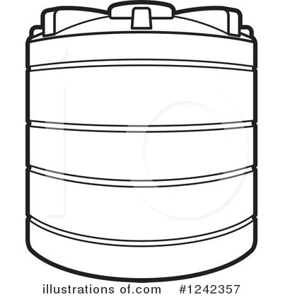  - Below are two tanks of water.  A  220litres  B  200litres  - Which tank has more water? | (1 mark)
- Which tank has 200 litres? | (2marks)
- Find the total amount of water in both tanks. | (2 marks)
- Shade the given fractions. | (6 marks)
  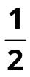 | 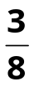 | 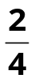
- Work out:  - + 5 = 7  - ÷ 6 = 2  - x 3 = 9 | (2 marks)  (2 marks)  (2 marks)
- The graph below shows the number of books which were given out to P.3 classes.  Streams  Number of books  YELLOW  GREEN  RED  PURPLE  BLUE  60  50  40  30  20  10  0  - Which class got the smallest number of books? | (1 mark)
- Which two classes got the same number of books? | (2 marks)
- How many more books did Green get than Purple? | (2 marks)

************ END ***************

